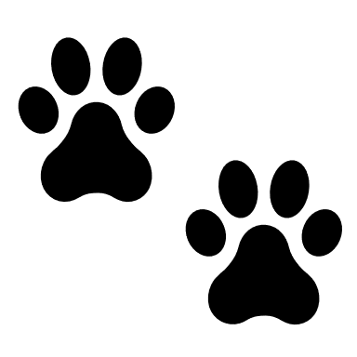

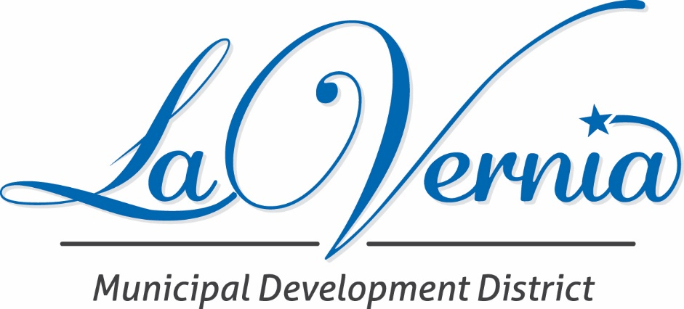

La Vernia Bears Incentive Program
APPLICATION AND INSTRUCTIONS

BEAR INCENTIVE PROGRAM

La Vernia Municipal Development District Bear Incentive Program Guidelines
The LVMDD will consider, on a case-by-case basis, and may award by its sole discretion a grant incentive to the owner of a commercial or industrial building within the city limits of La Vernia for the purchase of a bear statue.
- Only one bear will be approved for reimbursement per site location (if you are a strip center this means only one.)
- Applicants are allowed to propose any bear they would like for consideration.
- We are looking for applicants who showcase their intent to increase curb appeal, thus, the bear should be primarily focused and facing in such a way that would be seen from the “curb.”
- To receive a grant incentive, the applicant must NOT purchase the bear before consideration by the LVMDD.
- The applicant/ owner will submit an invoice for the proposed bear to the LVMDD Executive Director or designee for consideration attached to this application. The drawings/ invoice will illustrate the planned bear to be selected by the applicant. The drawing will need to be accompanied by cost estimates.
- The applicant must submit photos of the completed bear installation and a receipt of all costs incurred before the reimbursement money will be distributed.
- The applicant is expected to complete the installation of the bear that was presented in this application and agreed upon by the LVMDD Executive Director or designee in order to be reimbursed.
- LVMDD will approve up to a maximum of $1000 going to each applicant or 50% of the actual cost of the bear, whichever is less. The LVMDD Executive Director or designee shall certify proof of expenditures, the date the project is completed, and must recommend payment before funds are disbursed by the LVMDD.
- The LVMDD may not expend more than $20,000 in this grant program from October 1st to September 30th each year.
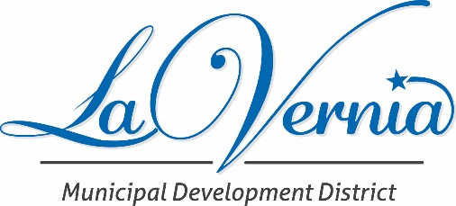

Name:
Phone and email address
Address and Legal Description of Property (applicant may attach maps and other illustrations)
Describe the proposed Bear in detail. Attach images and estimates. The LVMDD Board may require the submission of product samples and other technical information pertinent to the design review decisions.

Desired Start Date Completion Date ______
Total Cost Projected Grant amount

Signature of Applicant Date

For LVMDD Office Use
Application Received
Meeting Date and presentation made:
Decision of the LVMDD Board of Directors:
Date applicant is notified:
LA VERNIA MUNICIPAL DEVELOPMENT DISTRICT STANDARD AGREEMENT FOR THE FAÇADE GRANT PROGRAM

